Princess Sumaya University for Technology

King Abdullah II Faculty of Engineering

Electrical Engineering Department



|  |
| --- |
| **Embedded Systems NO. 22442**  **Final Project**  **MediBot** |

|  |  |  |
| --- | --- | --- |
| *Authors:* |  |  |
| Yara Altamimi | 20210561 | Electronics Engineering |
| Abdullah Matar | 20210720 | Computer Engineering |
| Nedal Abu-Haltam | 20210125 | Computer Engineering |

*January 11, 2025*

***Abstract***

*This report delves into the design and implementation of MediBot, a robotic nurse implemented as a car using PIC16F877A. MediBot has two modes, the first mode is the following mode, this mode makes the car follow its owner wherever they go and monitors and displays the temperature and humidity at all times. The other mode is the medical mode, this mode is activated by pressing a button that switches between the following and medical modes, in this mode the car is stationary and there are two options in this mode, both activated by pressing push buttons, the first option is to measure and display the Beat Per Minute (BPM) using the SparkFun sensor. The second option is to dispense pills to the user in order. The implementation was successful and assured it satisfied all the requirements expected.*

Table of Contents

1 Introduction 2

1.1 Objectives 3

1.2 Theory 4

2 Design 12

2.1 Operational Workflow 12

2.2 System Components 13

3 Results 15

4 Challenges 16

5 Conclusion 16

6 References 17

# Introduction

Healthcare has always been a critical area for technological innovation, with automation and robotics playing an increasingly vital role in enhancing the quality of patient care and reducing the burden on healthcare providers. In this context, the development of MediBot—a robotic nurse in the form of a car—demonstrates the potential of embedded systems to address real-world healthcare challenges.

MediBot is designed to assist users in a home or clinical setting by integrating essential health-monitoring and assistance functionalities into a compact, mobile platform. This project leverages the PIC16F877A microcontroller to implement a system capable of operating in two distinct modes: a **following mode** and a **medical mode**. The following mode enables MediBot to autonomously follow its user, providing constant monitoring and real-time display of temperature and humidity. In contrast, the medical mode transforms MediBot into a stationary assistant, offering advanced features such as heart rate measurement using a SparkFun sensor and automated pill dispensing.

The project encapsulates a comprehensive approach to system design, combining sensors, actuators, and microcontroller programming to create a reliable and user-friendly solution. This introduction outlines the motivations, objectives, and scope of MediBot, paving the way for a detailed discussion of its design, implementation, and performance in the subsequent sections of this report.

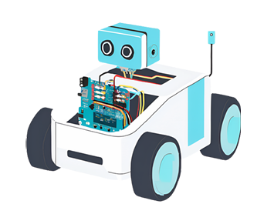

Figure : MediBot Design Inspiration

## Objectives

The development of MediBot involved the integration of several hardware components and sensors, each playing a crucial role in achieving the desired functionalities. Below are the key objects utilized in the project:

1. PIC16F877A Microcontroller

• The core processing unit of the system, responsible for controlling the inputs and outputs of MediBot.

• Provides efficient handling of multiple tasks such as sensor data processing, motor control, and user interface management.

1. SparkFun Pulse Sensor

• Measures the user’s heart rate (beats per minute, BPM) by detecting the pulse from the fingertip.

• Provides analog data that is processed by the microcontroller to display the BPM.

1. DHT11 Sensor

* Monitors environmental parameters such as temperature and humidity.
* Facilitates real-time display of environmental data in the following mode.

1. DC Motors and Motor Driver Circuit

* Drives the mobility of MediBot in the following mode.
* Controlled by the microcontroller to ensure accurate following behavior.

1. Ultrasonic Sensor

* Detect obstacles and assist in maintaining an optimal distance between MediBot and its user.
* Enhances the safety and reliability of the system.

1. LCD Display

* Displays real-time information such as temperature, humidity, BPM, and system status.
* Improves user interaction and accessibility, uses a potentiometer to control the contrast.

1. Push Buttons

* Enable the user to switch between the two modes (following mode and medical mode) and interact with the features in the medical mode and the Master-Clear button (MCLR).
* Provides a simple and intuitive interface.

1. Pill Dispenser Mechanism

* Dispenses pills in an orderly fashion during the medical mode.
* Uses the servo motor to rotate and dispense the pills.

1. Switch

* A simple switch that allows users to turn on/off the system.

## Theory

The design and operation of MediBot are grounded in several theoretical principles and concepts from embedded systems, robotics, and biomedical sensing:

1. **PIC16F877A Microcontroller**

The PIC16F877A microcontroller is an 8-bit microcontroller with RISC architecture. It operates as the central processing unit (CPU) for the system, controlling inputs and outputs, executing programs, and managing peripherals. It uses digital and analog pins for interfacing sensors, actuators, and other devices.

* **Key Features:**
* 40 I/O pins for versatile interfacing.
* Supports PWM, analog-to-digital conversion (ADC), and interrupts, making it ideal for real-time embedded applications.
* **Applications in MediBot:**  
  Processes sensor data, controls motor drivers, and manages user interface components such as buttons and the LCD.

Figure : PIC16F877A Microcontroller

1. **SparkFun Pulse Sensor**  
   Based on the principle of photoplethysmography (PPG), this sensor measures changes in blood volume by detecting light absorbed or reflected by blood vessels. The analog signal is processed by the microcontroller to calculate the heart rate (BPM).

* **Applications in MediBot:**  
  Used in the medical mode to monitor the user’s heart rate and display the results.

Figure : Heart Rate Sensor

1. **DHT11 Sensor**

The DHT11 is a digital temperature and humidity sensor that uses capacitive and resistive elements to measure environmental conditions. The microcontroller reads digital data from the sensor and processes it for display.

* **Applications in MediBot:**  
  Provides real-time environmental data in the following mode, ensuring user awareness of the surroundings.

Figure : Temperature and Humidity Sensor

1. **DC Motors and Motor Driver Circuit**

DC motors convert electrical energy into mechanical motion, enabling movement. A motor driver circuit (such as H-bridge) is used to control the motors, allowing bidirectional movement and speed regulation via PWM signals.

* **Applications in MediBot:**  
  Drives the robotic platform, enabling it to follow the user or remain stationary as required.

Figure : DC Motor

1. **Ultrasonic Sensors**

Ultrasonic sensors emit high-frequency sound waves and calculate the distance to an object based on the time taken for the echo to return. This principle of echolocation is used for obstacle detection.

* **Applications in MediBot:**  
  Maintains a safe following distance between MediBot and its user in the following mode.

Figure : Ultrasonic Sensor

1. **LCD Display**

An LCD uses liquid crystal technology to display alphanumeric characters and symbols. The microcontroller controls the LCD via parallel or serial communication. A potentiometer adjusts the contrast by varying the voltage to the display.

* **Applications in MediBot:**  
  Displays temperature, humidity, BPM, and system status for easy user interaction.

Figure : LCD Display

1. **Push Buttons**

Push buttons provide a simple interface for user input. When pressed, they create a connection between two terminals, sending a digital signal to the microcontroller. The Master-Clear (MCLR) button is a reset feature to reinitialize the system.

Figure : Push Button

1. **Pill Dispenser Mechanism**

A servo motor is used in the pill dispenser mechanism for precise control. Servo motors operate based on PWM signals, which determine the angle of rotation. The servo ensures accurate and orderly dispensing of pills.

* **Applications in MediBot:**  
  Dispenses pills sequentially in the medical mode, improving usability and reliability.

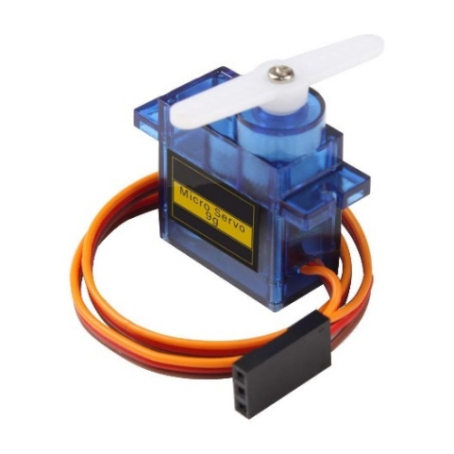

Figure : Servo Motor

1. **Switch**

A switch is a basic electrical component used to enable or disable the flow of current in a circuit. In this system, the switch serves as a power control mechanism.

* **Applications in MediBot:**  
  Allows the user to turn the system on or off, ensuring ease of operation and power conservation.

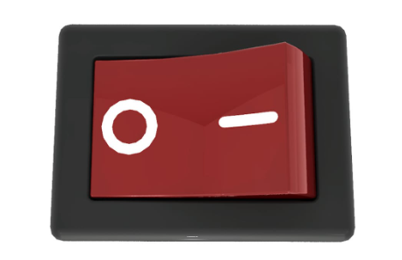

Figure : Electrical Switch

1. **H-bridge**

The H-bridge circuit is a combination of four switches (often transistors or MOSFETs) arranged in an "H" configuration. By controlling which switches are activated, current flows in different directions through the motor, allowing bidirectional movement. PWM signals are used to control motor speed.

* **Applications in MediBot:** Enables precise motor control for movement in the following mode.

Figure : H-Bridge

1. **IR Sensors**

Infrared sensors work by emitting infrared light and detecting its reflection. When the sensor detects a surface with low reflectivity (e.g., black lines), it signals the microcontroller.

* **Applications in MediBot**: Enables precise motor control for movement in the following mode.

Figure : IR Sensor

1. **Lithium-Ion Batteries**

Lithium-ion batteries are rechargeable and offer high energy density, lightweight design, and long-life cycles. They typically operate at a nominal voltage of 3.7V per cell.

* **Applications in MediBot:** Provides power to the microcontroller, motors, and peripherals, ensuring consistent operation.

Figure : Lithium-Ion Battery

1. **Car Body**

A well-designed chassis provides structural support, protects internal components, and ensures stability during operation. Materials like plastic, aluminum, or acrylic are often used for their lightweight and durable properties.

* **Applications in MediBot:** Houses components, maintains balance, and provides aesthetic appeal.

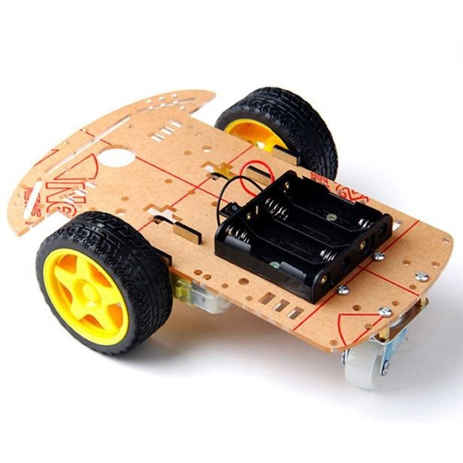

Figure : The Body of a 2WD Car

1. **Buzzer**

A piezoelectric buzzer generates sound when an AC voltage is applied to its piezoelectric element. The frequency of the voltage determines the tone of the sound.

* **Applications in MediBot:** Alerts users to specific events, such as errors, mode transitions, or successful operations.

Figure : Buzzer

1. **LEDs**

Light Emitting Diodes (LEDs) emit light when current flows through them in the forward direction. Different colors indicate specific statuses, and blinking patterns can signal alerts or activity.

* **Applications in MediBot:** Visual indicators for system power, mode selection, or error states.

Figure : LED Structure

# Design

MediBot is an innovative robotic assistant designed to provide healthcare support through two distinct operational modes: **following mode** and **medical mode**. The system combines advanced sensing, actuation, and processing capabilities, implemented using the PIC16F877A microcontroller, to achieve a seamless and user-friendly experience.

## Operational Workflow

1. **Following Mode:**

* The user activates the system via a switch, and MediBot enters the following mode.
* Ultrasonic sensors guide the robot to maintain an optimal distance while following the user.
* Environmental conditions (temperature and humidity) are displayed continuously on the LCD.

1. **Medical Mode:**

* The user switches to medical mode using a push button.
* In this mode:
  + BPM can be measured using the SparkFun Pulse Sensor, and the results are displayed on the LCD.
  + A pill dispenser mechanism, controlled by a servo motor, provides medication in a pre-defined sequence.

The following figure displays the flowchart of the workflow of MediBot:

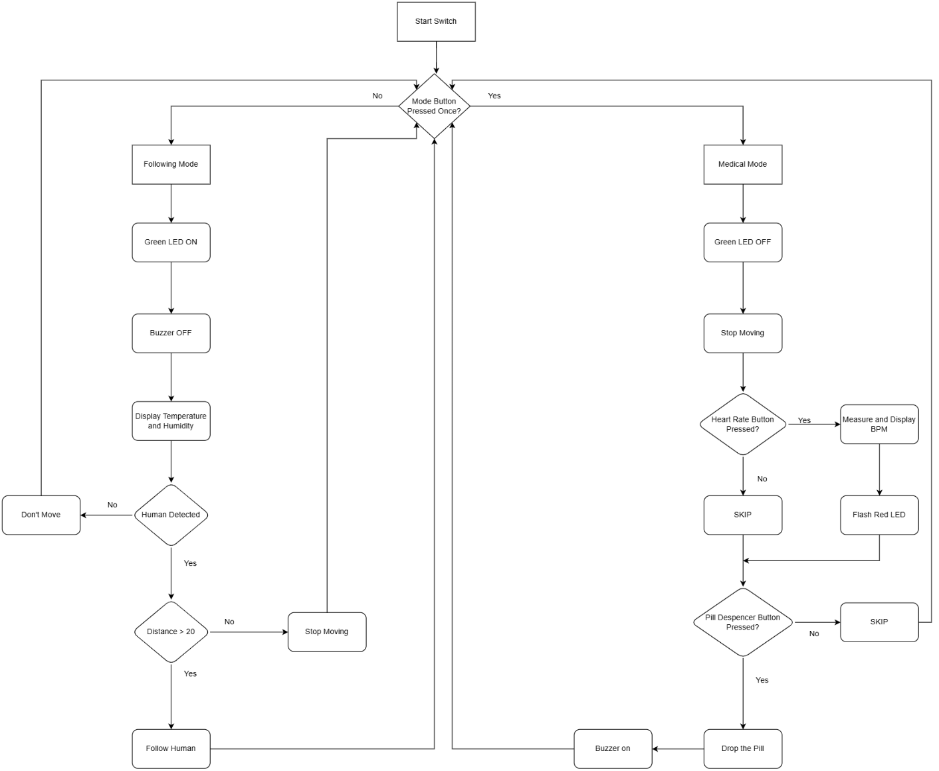

Figure : Flowchart of the Design

## System Components

The system integrates multiple hardware and software components to achieve its functionality, these are some of the most important ones used:

* **Sensors:**
* Ultrasonic sensors for obstacle detection and user tracking.
* DHT11 sensor for temperature and humidity monitoring.
* SparkFun Pulse Sensor for BPM measurement.
* IR sumo sensors for edge detection.
* **Actuators:**
* DC motors (controlled by an H-bridge) for movement.
* Servo motor for pill dispensing.
* **Power Supply:**
* Lithium-ion batteries to provide reliable power to all components.
* **User Interface:**
* Push buttons for mode selection and feature activation.
* LCD for displaying system status, environmental data, and BPM.
* LEDs and a buzzer for visual and audio feedback.

The following figure displays the schematic design of MediBot using Proteus:

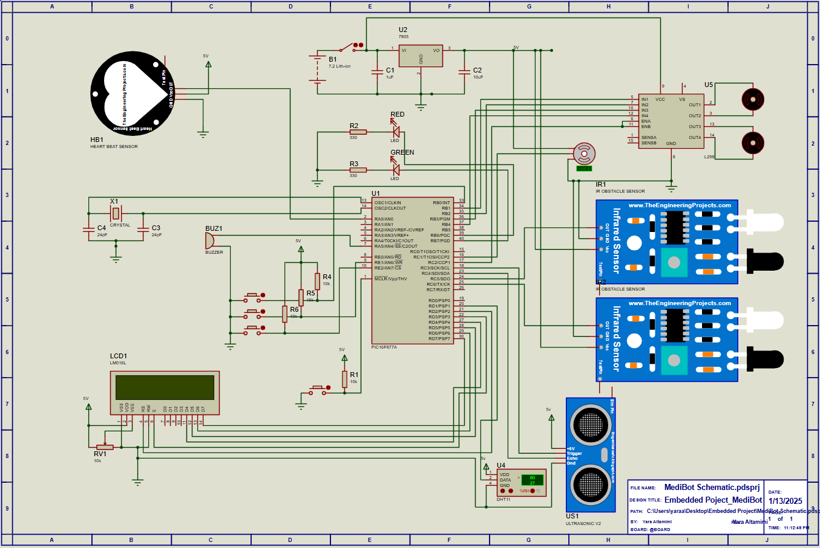

Figure : Schematic of the Design

# Results

The implementation and testing of MediBot yielded promising results, successfully achieving the objectives outlined in the project.

Here are some pictures of our design from several angles:

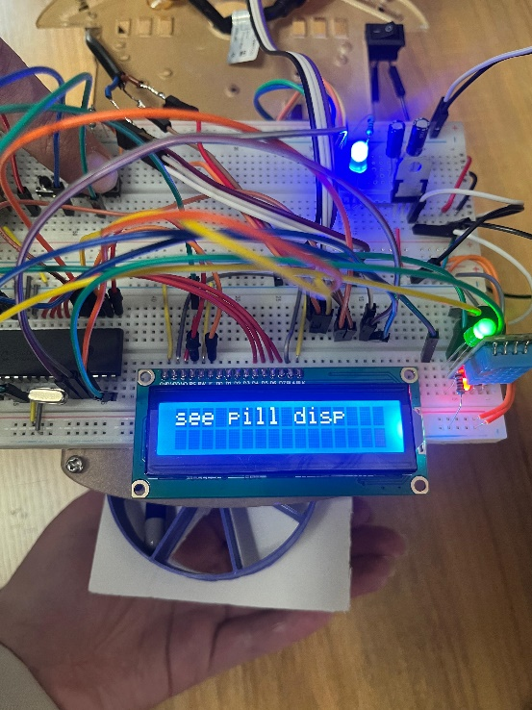

# Challenges

**Pill Dispenser Alignment:**  
Ensuring that the pill dispensing mechanism aligned perfectly with the pill slot was challenging. This required precise mechanical adjustments and software coordination.

**Challenges with the Heart Rate Sensor:**

We started by using the MAX30102 which was supposed to measure the BPM, SPO2 and Human body temperature, but due to it needing I2C and lack of resources on it since it is a somewhat new sensor, we weren’t able to implement in an ideal way to display accurate results. Then, we moved on to the SparkFun sensor (Copy), we implemented it but again it was inaccurate. After that we tried the MAX30100, and we discovered that it has a manufacturing issue that makes it unusable at all. Finally, integrating the SparkFun Pulse Sensor (Original) presented challenges due to timer conflicts on the PIC16F877A microcontroller. Timer0 was allocated for ultrasonic sensing, Timer1 for the servo motor, and Timer2 for PWM control, leaving no dedicated timer for the heart rate sensor. This caused resource conflicts and inaccurate BPM readings. We solved this issue by using another PIC microcontroller that is responsible only for measuring BPM and interfacing with the SparkFun sensor.

# Conclusion

The MediBot project demonstrates the successful integration of embedded systems and robotics to address practical healthcare needs. Designed and implemented using the PIC16F877A microcontroller, MediBot serves as a versatile robotic nurse capable of performing two distinct roles: assisting users with environmental monitoring and mobility in the following mode, and providing medical assistance in the medical mode.

The system’s ability to autonomously follow its user, measure vital parameters like heart rate, and dispense medication highlights its potential as a reliable and user-friendly healthcare assistant. Each component, from the sensors and actuators to the power supply and user interface, was carefully selected and integrated to ensure the system operates efficiently and effectively.

**Future Scope and Recommendations:**

1. **Additional Sensors:** Incorporation of more medical sensors, such as SpO2 or blood pressure monitors, for comprehensive health monitoring.
2. **Remote Control and Monitoring:** Development of a mobile app or web interface for remote operation and data tracking.

# References

|  |  |
| --- | --- |
| [1] | <https://ww1.microchip.com/downloads/en/devicedoc/39582b.pdf> |
| [2] | <https://circuitdigest.com/microcontroller-projects/heartbeat-monitoring-using-pic-microcontroller-and-pulse-sensor> |